MyTaxi System

Use Case: <UC_002– Register>

Version <0.1>

Revision History

|  |  |  |  |
| --- | --- | --- | --- |
| Date | Version | Summary of Change | Author |
| 07 Jun, 2016 | 0.1 | Initial version | Tu Le  Nghi Phan  Phuong Do  Duyen Phan |

Distribution for Review/Approval

|  |  |  |  |  |  |
| --- | --- | --- | --- | --- | --- |
| Name | Title & Company | Issue Version | Issue Date | Review Date | Approval Date |
| Doan Vo | BA Lead - BAC | 0.1 | 07 Jun, 2016 | 09 Jun, 2016 |  |
|  |  |  |  |  |  |
|  |  |  |  |  |  |

Contents

1 Introduction 2

2 Processes 2

3 Flow of Events 2

3.1 Basic Flow: <Flow Name> 2

3.2 Alternative Flow: <Flow Name> 2

3.3 Exception Flows 2

3.3.1 Exception Flow 1: <Flow Name> 2

3.3.2 Exception Flow 2: <Flow Name> 2

3.3.3 Exception Flow n: <Flow Name> 2

4 Business Rules 2

5 Special Requirements 2

6 Supplementary Information 2

7 Related Documents 2

# Introduction

|  |  |
| --- | --- |
| ID and Name | UC_002 Register |
| Description | Allow driver and passenger to register with their personal information and they can use them to login this application. |
| Actor | * Driver * Passenger |
| Relationships | Includes:  Extends:   * Login |
| Pre-conditions | * Project status: login completed and data recorded in the DB. * The system informs end user of the end of the register process. |
| Post-conditions | * Newly account with entered data is created in DB. * In case of cancellation of the registration process (Basic Flow step 4), the actor will be no more accessible with their information (email/password). |

# Processes

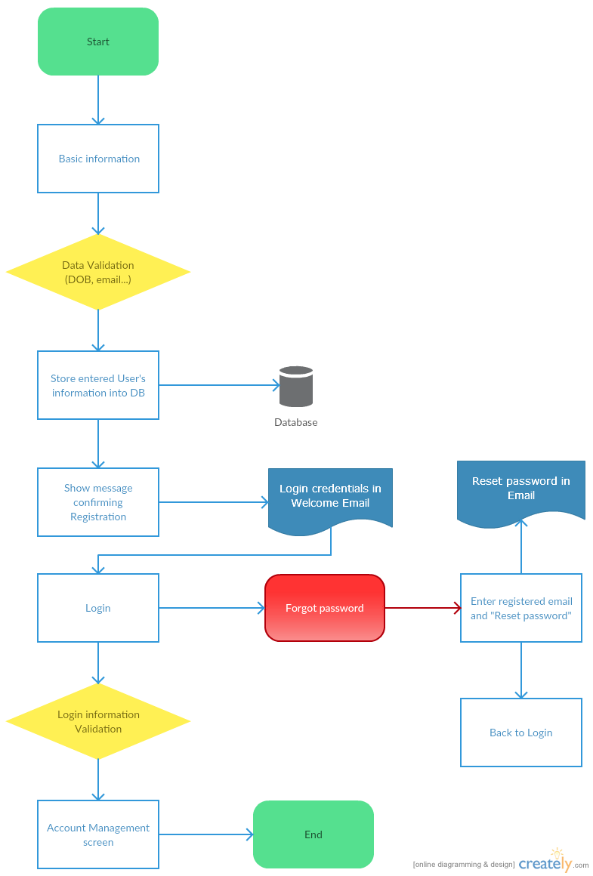

# Flow of Events

## Basic Flow:

## Basic Flow: < Driver registration>

|  |  |
| --- | --- |
| **Step** | **Description** |
|  | The actor open application in his/her mobile |
|  | The Login page is displayed |
|  | Actor clicks “Become a driver” button |
|  | The registration page is displayed with  + “Already have an account?” button  + “Create a new account” section included below items:  1/ First name textbox  2/ Last name textbox  3/ Email textbox  4/ Phone textbox  5/ Password textbox  6/ City dropdown list  7/ Create account button  8/ Cancel button |
|  | Actor entered data in “Create a new account” section:  1/ First name textbox  2/ Last name textbox  3/ Email textbox  4/ Phone textbox  5/ Password textbox  6/ City dropdown list |
|  | Confirm actor can entered data in “Create a new account” section is successful |
|  | Actor clicks “Submit” button to saves data |
|  | 1/ The system launches the validation process  + Checking that the actor’s email is/are existing in the DB.  + Checking that the actor’s phone is/are existing in the DB.  2/ The system displays the result of the validation:  + In case of successful, system saves data into DB and displays the successful message |
|  | Login with registered email & password  Clicks “Login” button |
|  | 1/ The system launches the validation process  + Checking that the actor’s email is/are existing in the DB.  + Checking that the actor’s password is/are existing in the DB.  2/ The system displays the result of the validation:  + In case of successful, system displayed the “Account management” screen |
|  | The end |

## 3.1.2 Basic Flow: < Passenger registration >

|  |  |
| --- | --- |
| **Step** | **Description** |
|  | The actor open application in his/her mobile |
|  | The Login page is displayed |
|  | Actor clicks “Start ridding with My Taxi” button |
|  | The registration page is displayed with  + “Already have an account?” button  + “Sign Up to Ride” section included below items:  1/ First name textbox  2/ Last name textbox  3/ Email textbox  4/ Phone textbox  5/ Password textbox  6/ City dropdown list  7/ Credit Card Number textbox  8/ CVV textbox  9/ Expiration Date: calendar field  10/ Create account button  11/ Cancel button |
|  | Actor entered data in “Sign Up to Ride” section:  1/ First name textbox  2/ Last name textbox  3/ Email textbox  4/ Phone textbox  5/ Password textbox  6/ City dropdown list  7/ Credit Card Number textbox  8/ CVV textbox  9/ Expiration Date: calendar field |
|  | Confirm actor can entered data in “Sign Up to Ride” section is successful |
|  | Actor clicks “Create account” button to saves data |
|  | 1/ The system launches the validation process  + Validation for Payment fields (CC#, CVV, Expiration Date)  + Checking that the actor’s email is/are existing in the DB.  + Checking that the actor’s phone is/are existing in the DB.  2/ The system displays the result of the validation:  + In case of successful, system saves data into DB and displays the successful message |
|  | Actor clicks “Submit” button to saves data |
|  | 1/ The system launches the validation process  + Checking that the actor’s email is/are existing in the DB.  + Checking that the actor’s phone is/are existing in the DB.  2/ The system displays the result of the validation:  + In case of successful, system saves data into DB and displays the successful message |
|  | Login with registered email & password  Clicks “Login” button |
|  | 1/ The system launches the validation process  + Checking that the actor’s email is/are existing in the DB.  + Checking that the actor’s password is/are existing in the DB.  2/ The system displays the result of the validation:  + In case of successful, system displayed the “Account management” screen |
|  | The end |

## Alternative Flows:

### 3.2.1 Alternative Flows: < Registration failure >

|  |  |
| --- | --- |
| **Step** | **Description** |
| 1 | At the step 3 of the Basic flow, actor entered invalid data and clicks “Create account” button |
| 2 | The system will displayed the “Create new account” page with the list of errors |
| 3 | The end |

### 3.2.2 Alternative Flows: < Login failure>

|  |  |
| --- | --- |
| **Step** | **Description** |
| 1 | At the step 5 of the Basic flow, actor entered invalid data and clicks “Login” button |
| 2 | The system will displayed the Login page with the list of errors |
| 3 | The end |

## Exception Flows

### Exception Flow 1: <Flow Name>

<Description of this exception flow>

### Exception Flow 2: <Flow Name>

<Description of this exception flow>

### Exception Flow n: <Flow Name>

<Description of this exception flow>

# Business Rules

|  |  |
| --- | --- |
| **BR ID** | **Description** |
| BR1 | <Description, calculation logics, sample> |
| BR2 | <Description, calculation logics, sample> |
| BR3 | <Description, calculation logics, sample> |

# Special Requirements

<Only list out the non-functional requirements applied for this specific UC, not for the whole system. Normally it is performance requirement.>

# Supplementary Information

<Contain any additional materials that

* support to understand this use case better such as workflow, activity diagrams, data dictionary
* supplementary details for the completeness of this use case such as data specifications of entities used in the flows, message log
* golden data
* etc.

>

# Related Documents

<only needed if this document refers to many other documents, this section aims to give the readers a summary of all referenced documents>

|  |  |
| --- | --- |
| **When** | **Refer to** |
| <Purpose> | <Document ID – Name, storage location if possible> |